Ideation Phase - Define the Problem Statements
Date | 10 August 2026
Team ID | N/A
Author / Team Member | Aditya Kamble
Project Name | ShopEZ Ecommerce Application
Maximum Marks | 2 Marks

Customer Problem Statement Template:
Author: Aditya Kamble (Individual)
Create a problem statement to understand your customer's point of view. The Customer Problem Statement template helps you focus on what matters to create experiences people love.
A well-articulated customer problem statement allows you and your team to find the ideal solution for the challenges your customers and merchants face. Throughout the process, you will also be able to empathize with your customers, which helps you better understand how they perceive your e-commerce product or service.
Problem Statement | I am (Customer / User) | I'm trying to | But | Because | Which makes me feel
PS-1: Online Shopper - Discovery & Checkout | An active online consumer looking for electronics and lifestyle goods | Find authentic products quickly, inspect transparent reviews, and checkout seamlessly | Traditional portals are cluttered, slow, and enforce multi-page complex checkouts | Monolithic legacy stores do not offer streamlined SPA speed and instant cart calculations | Frustrated and impatient, leading to cart abandonment
PS-2: Seller / Merchant - Catalog & Stock Control | A small business seller selling on the ShopEZ marketplace | Upload product listings with images, adjust stock counts dynamically, and track low inventories | Existing seller dashboards are bloated, take too many clicks to edit a price, and fail to warn before running out of stock | Traditional admin portals lack inline editing and real-time inventory threshold alerts (< 10 units) | Overwhelmed by operational overhead and anxious about overselling out-of-stock items
PS-3: Platform Admin - Order Governance & Metrics | The store operations administrator managing overall platform health | Monitor gross sales revenue, manage registered users, and update multi-stage order fulfilment statuses | Order updates and customer records are scattered across disconnected tools without consolidated analytics | Lack of unified MERN-based centralized administration dashboards with role-based access control | Concerned about delayed order deliveries and poor operational visibility

Visual Problem Statement Canvas Diagram:

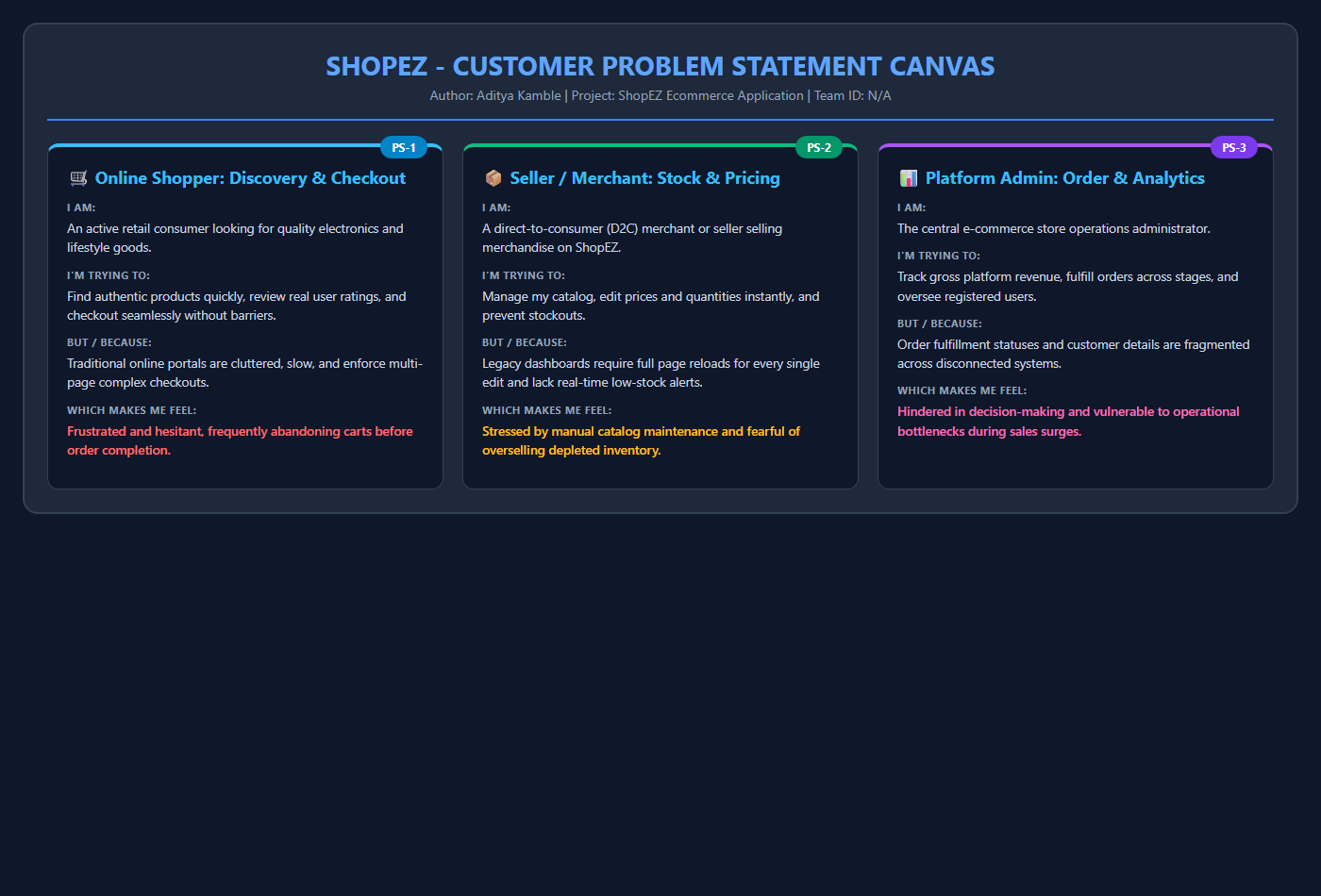
Figure 1: Customer Problem Statement Canvas for ShopEZ E-Commerce Platform

